Report 1:

The search functionality is not working, even if the searched term exists on the site

Used device/Browser:

* Chrome (Version 114.0.5735.199 (Official Build) (64-bit)) on Windows 10

Steps to reproduce:

* Open the <https://www.arngren.net/index.html> page
* Type something you want to search for in the search bar
* Click search button

Screenshot:

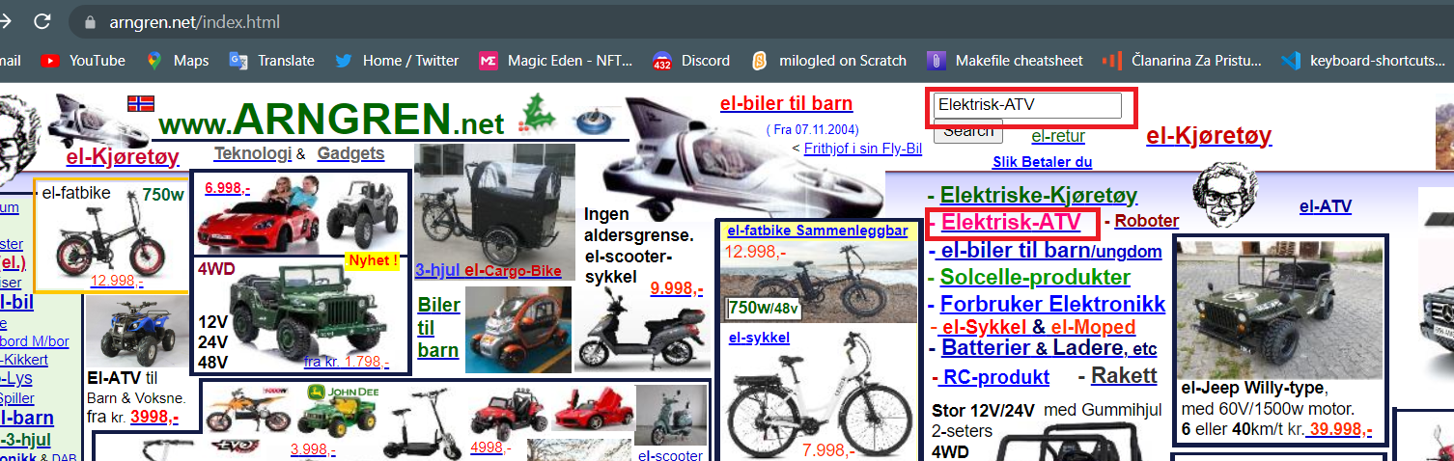

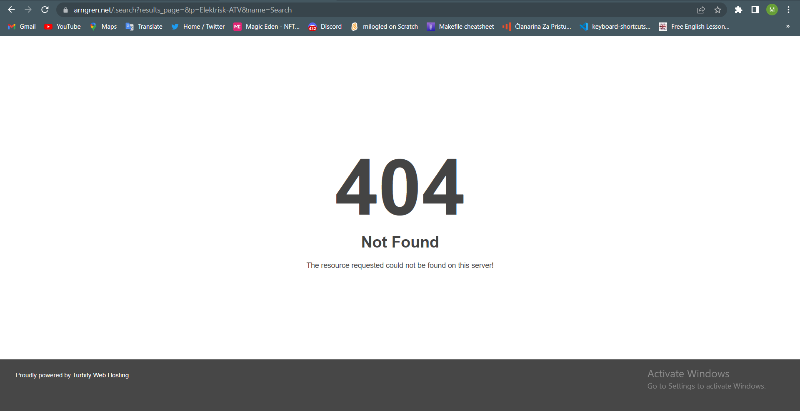

Report 2:

There are links to removed YouTube videos

Used device/Browser:

* Chrome (Version 114.0.5735.199 (Official Build) (64-bit)) on Windows 10

Steps to reproduce:

* Open the <https://www.arngren.net/pleo.html> page
* Click “video-3” link, or “video-4” link

Screenshot:

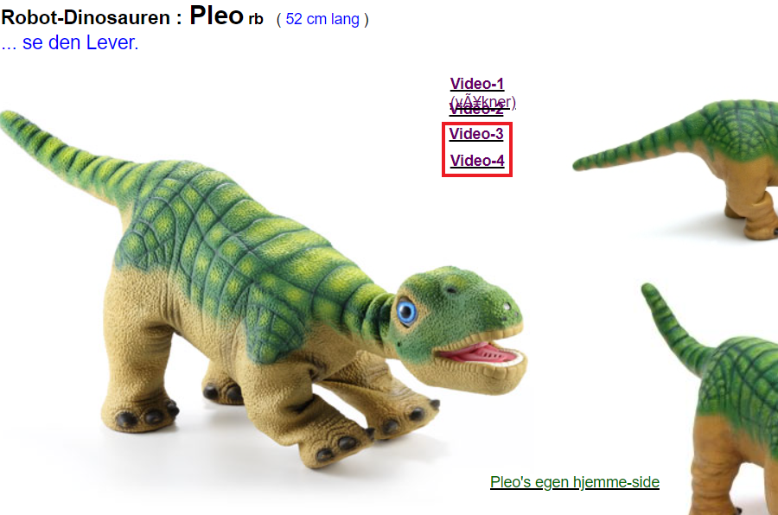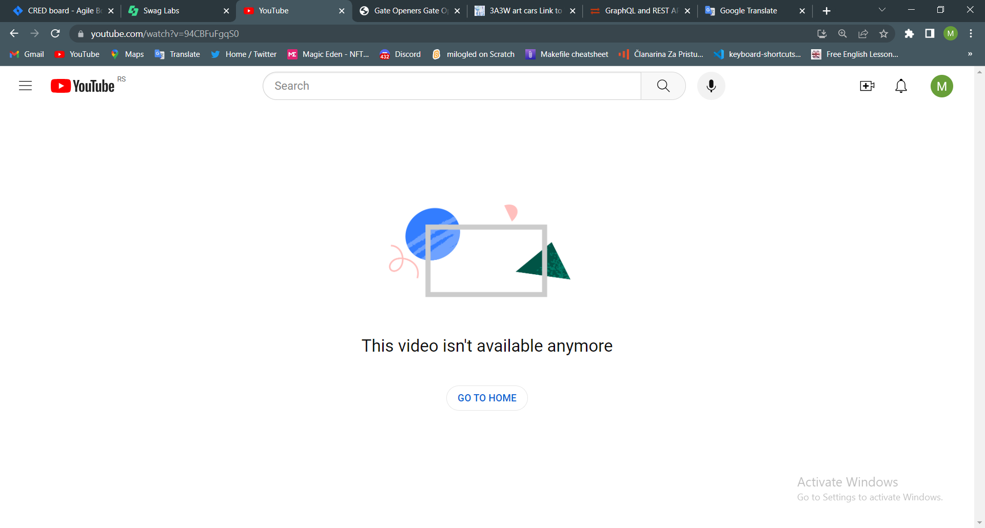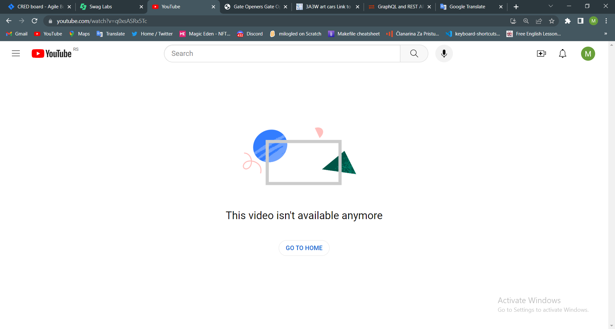

Report 3:

Two links from the product description are not working

Used device/Browser:

* Chrome (Version 114.0.5735.199 (Official Build) (64-bit)) on Windows 10

Steps to reproduce:

* Open the <https://www.arngren.net/pleo.html> page
* Scroll down to product information
* Click the first link from the description
* Go back
* Click the second link from the description

Screenshot:

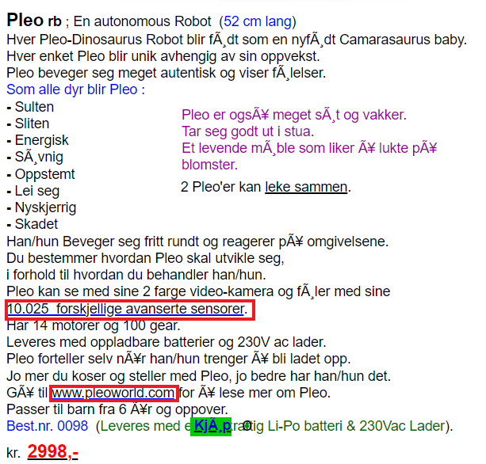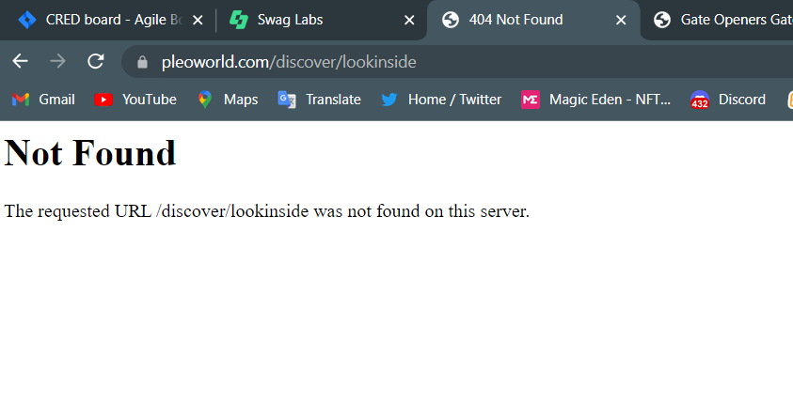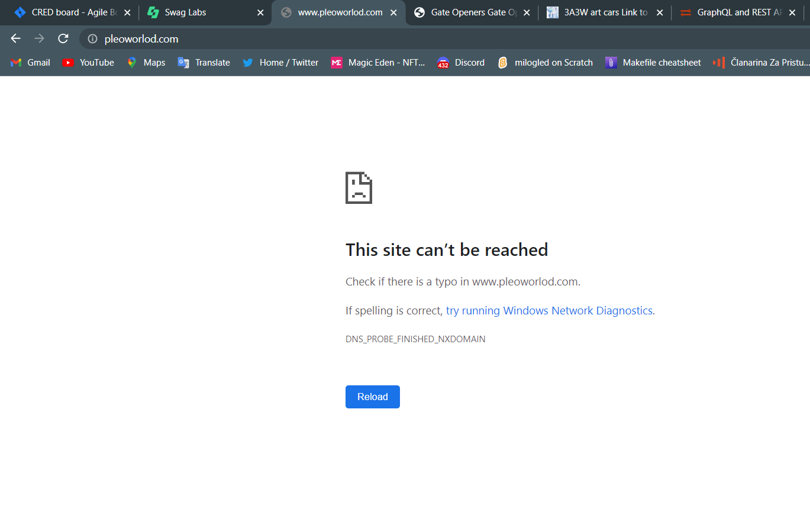

Report 4:

The guarantee seal link is not responding

Used device/Browser:

* Chrome (Version 114.0.5735.199 (Official Build) (64-bit)) on Windows 10

Steps to reproduce:

* Open the <https://www.arngren.net/pleo.html> page
* Scroll down to the bottom of the page
* Click the guarantee seal

Screenshot:

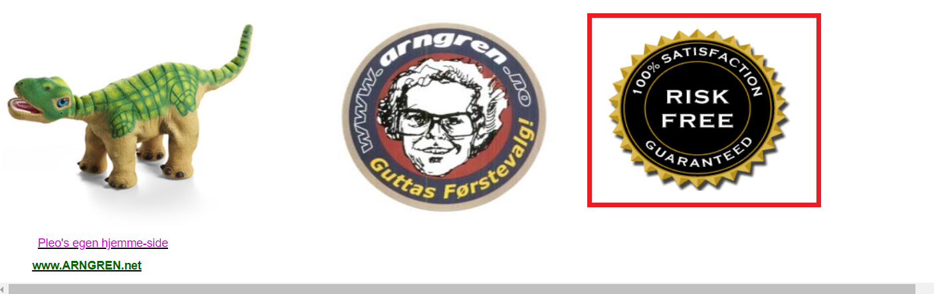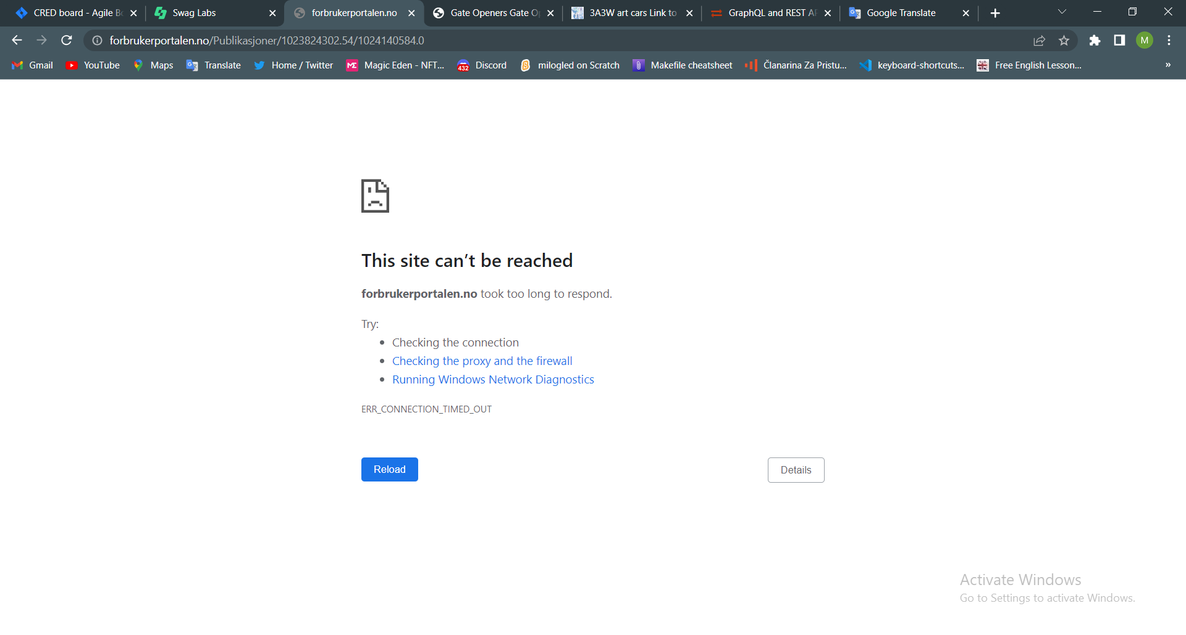

Here is the problem recorded ⬇️

<http://g.recordit.co/DxwNsjGEmz.gif>

Report 5:

There is a broken image

Used device/Browser:

* Chrome (Version 114.0.5735.199 (Official Build) (64-bit)) on Windows 10

Steps to reproduce:

* Open the <https://www.arngren.net/egg.html>, or <https://www.arngren.net/robotene.html>, or <https://www.arngren.net/teleskop.html>, <https://www.arngren.net/gutter.html>, or <https://www.arngren.net/piker.html>, or almost any other page on the site

Screenshot:

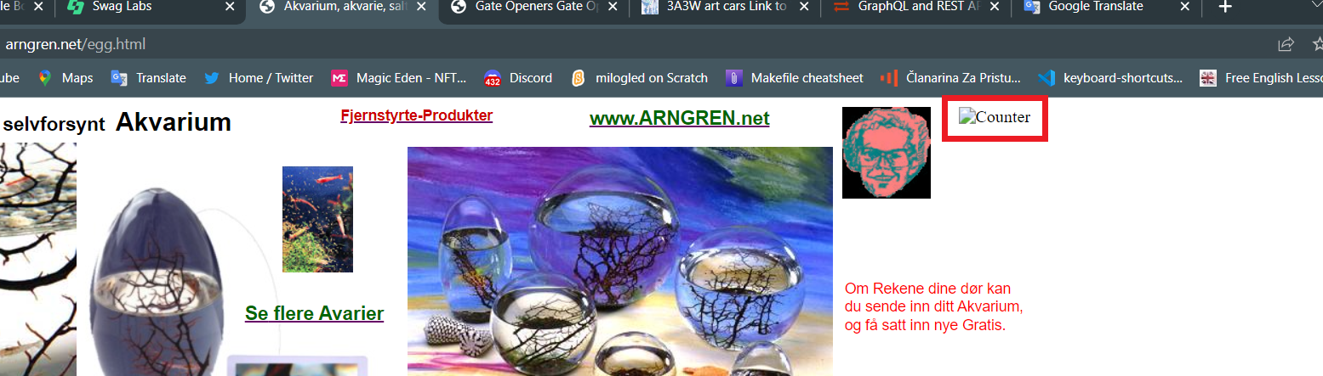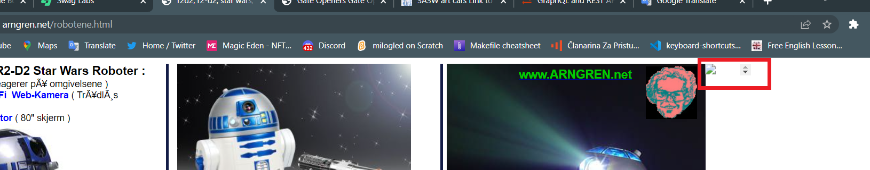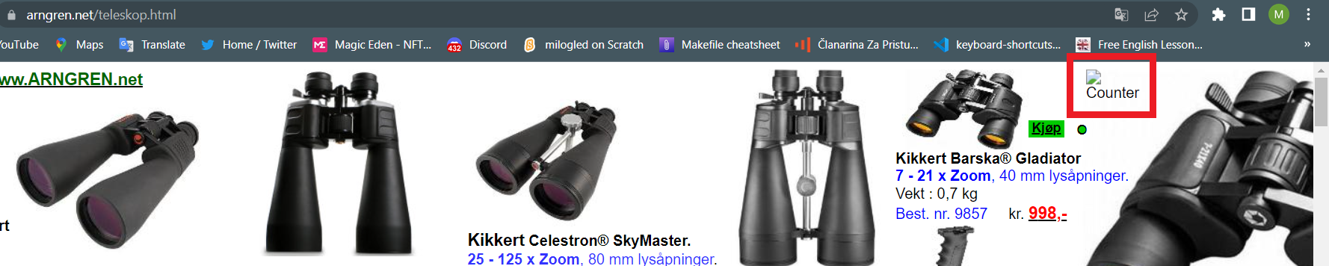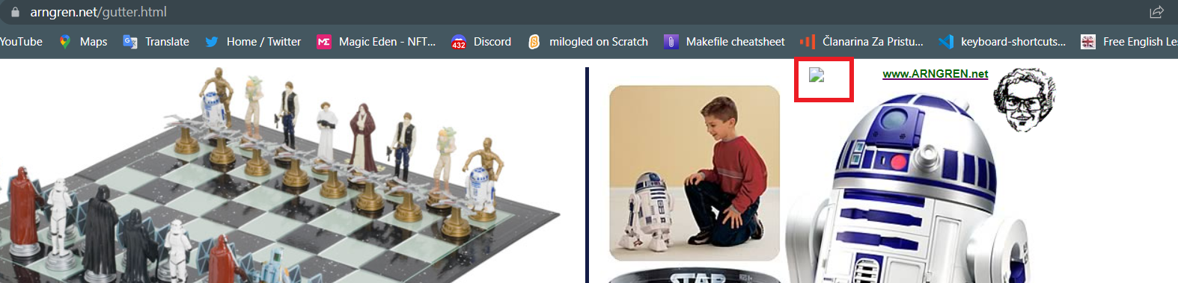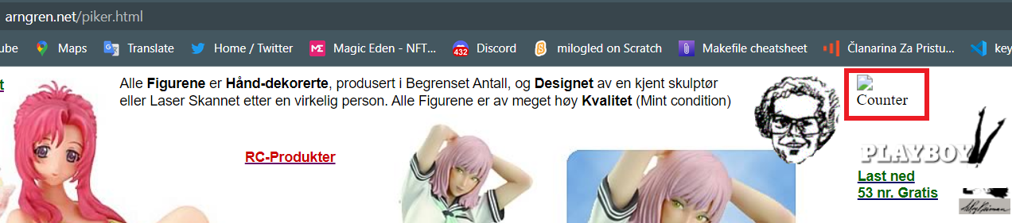

Report 6:

The link to the producer's site does not work

Used device/Browser:

* Chrome (Version 114.0.5735.199 (Official Build) (64-bit)) on Windows 10

Steps to reproduce:

* Open the <https://www.arngren.net/solceller.html> page
* Scroll down to the TUV company logo
* Click the round TUV company logo

Screenshot:

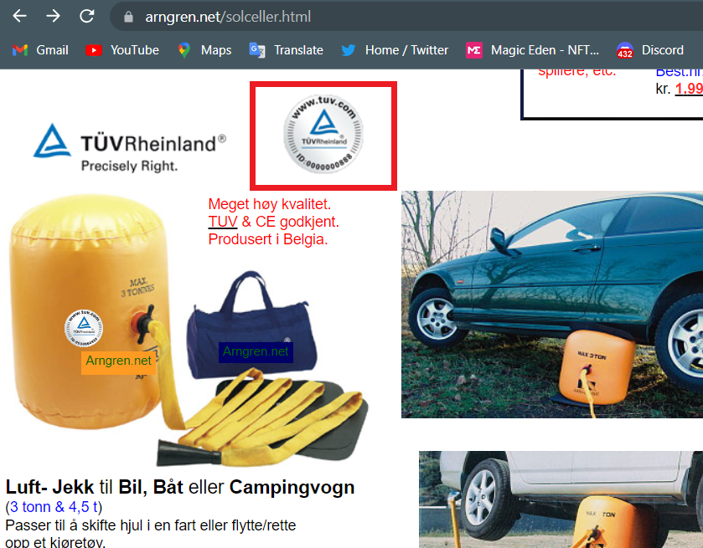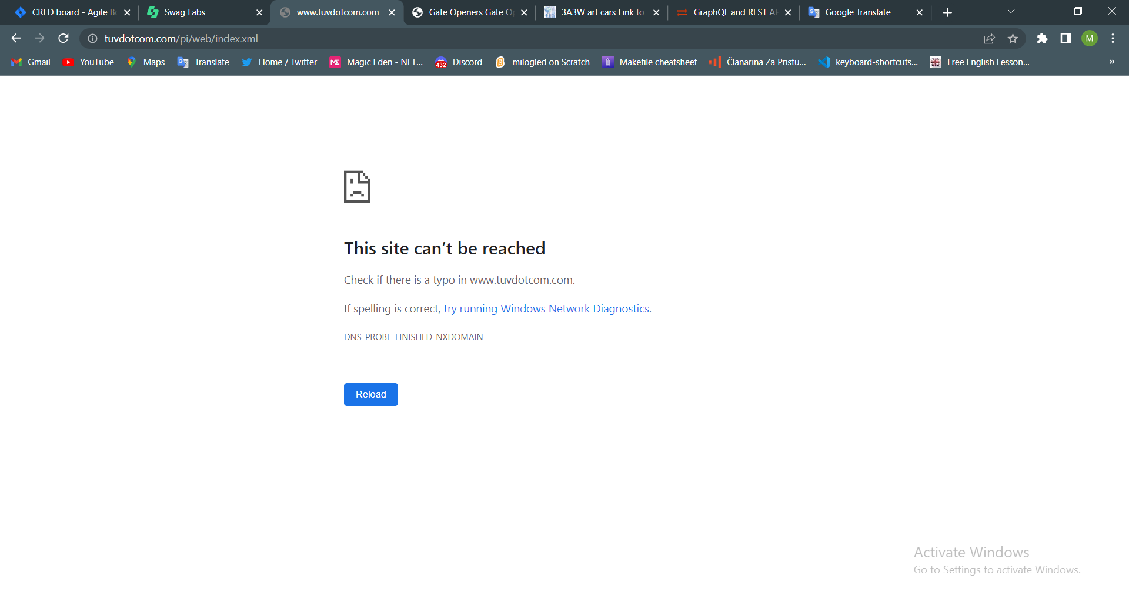

Report 7:

The link to the producer's site does not work

Used device/Browser:

* Chrome (Version 114.0.5735.199 (Official Build) (64-bit)) on Windows 10

Steps to reproduce:

* Open the <https://www.arngren.net/jeep.html> page
* Scroll down to the pictures with links in the description below them
* Click the link

Screenshot:

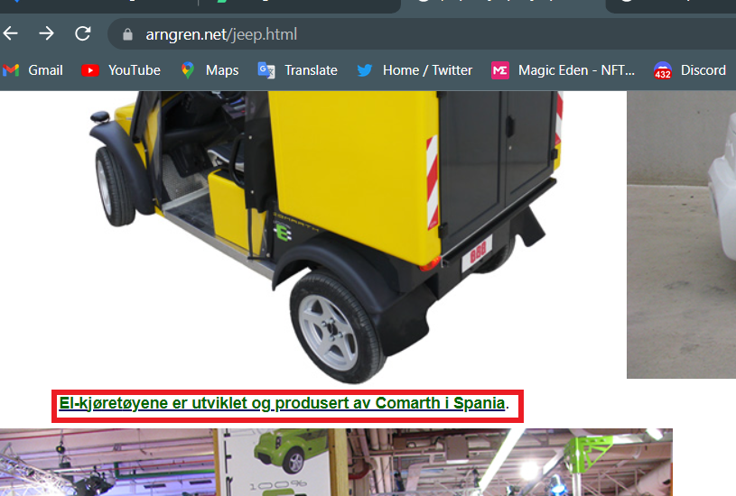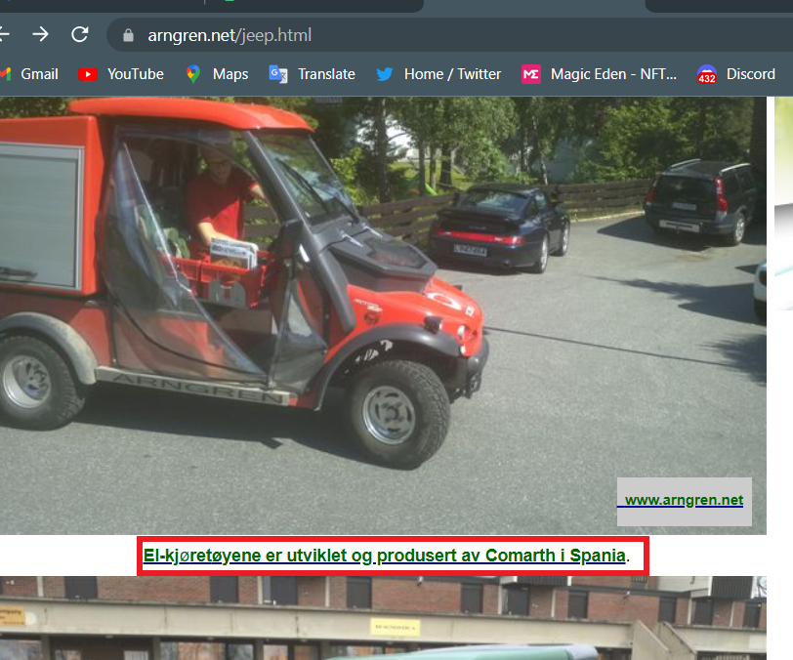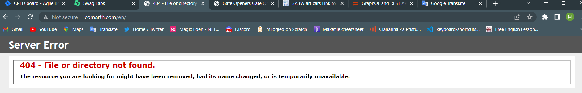

Report 8:

The link to the product page does not work

Used device/Browser:

* Chrome (Version 114.0.5735.199 (Official Build) (64-bit)) on Windows 10

Steps to reproduce:

* Open the <https://www.arngren.net/jeep.html> page
* Scroll down to the picture presented with the screenshot
* Click the picture

Screenshot:

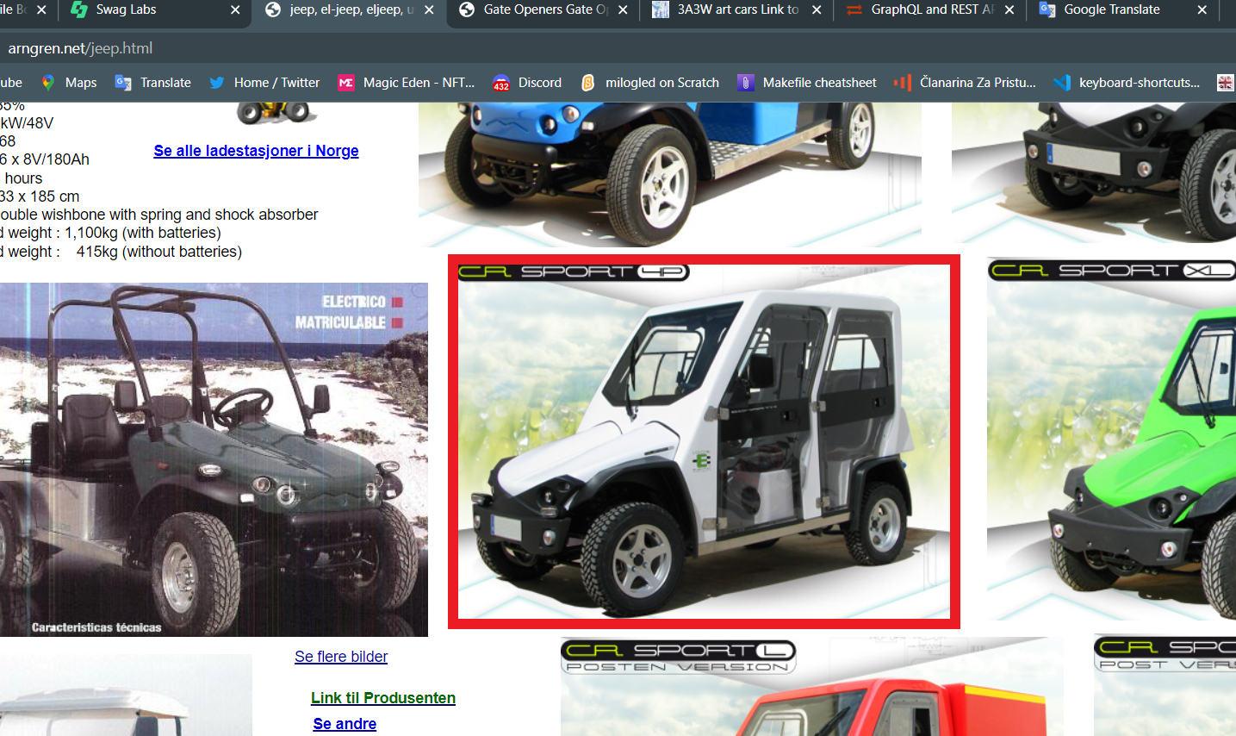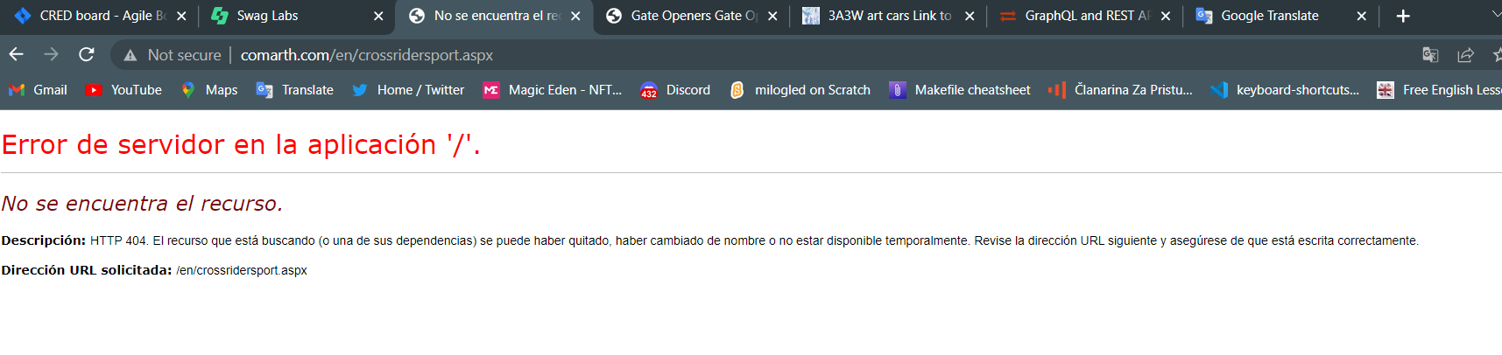

Report 9:

The link to the producer's site does not work

Used device/Browser:

* Chrome (Version 114.0.5735.199 (Official Build) (64-bit)) on Windows 10

Steps to reproduce:

* Open the <https://www.arngren.net/teleskop.html> page
* Scroll down to the bottom of the page
* Click the link

Screenshot:

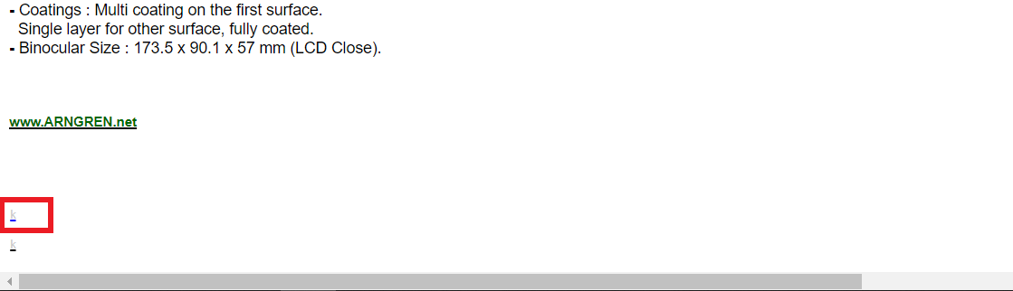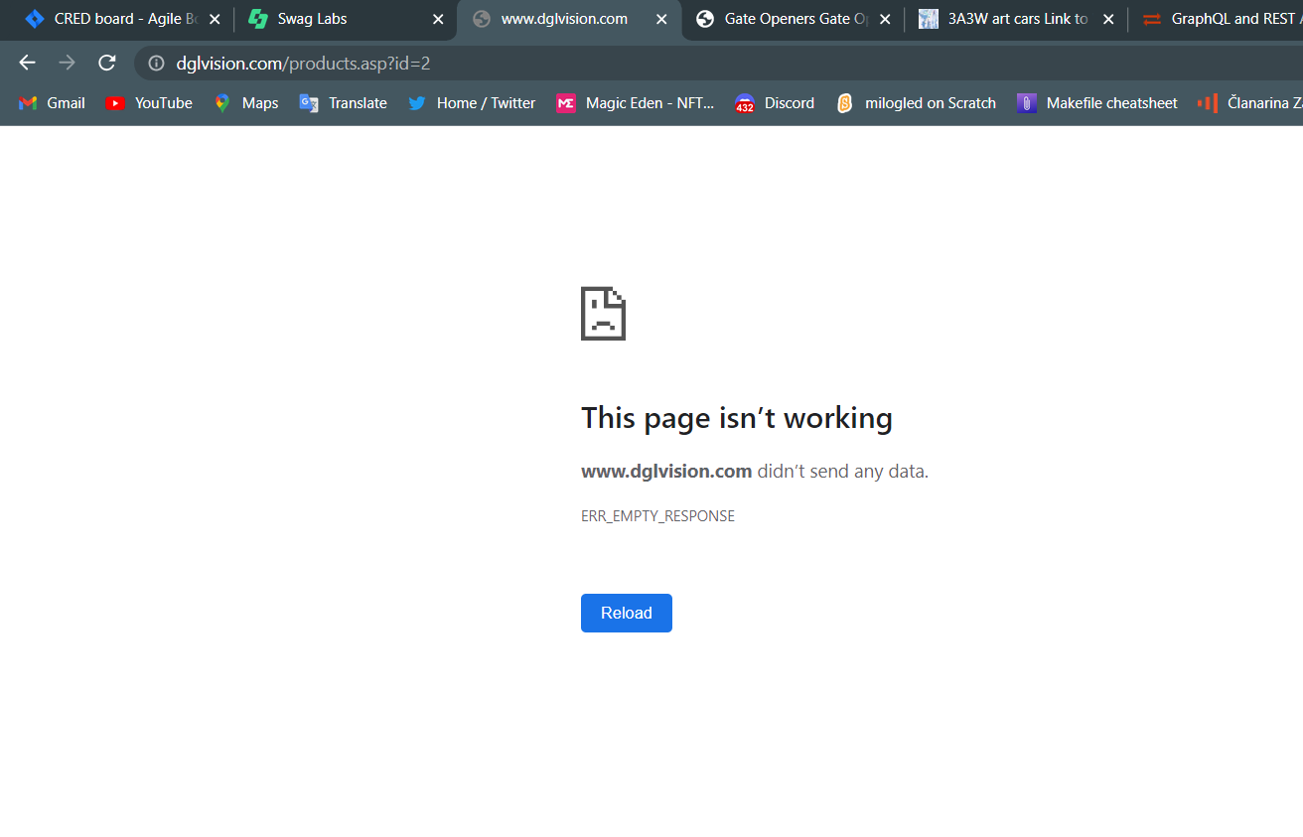

Report 10:

The link to the product page from Home Page does not work

Used device/Browser:

* Chrome (Version 114.0.5735.199 (Official Build) (64-bit)) on Windows 10

Steps to reproduce:

* Open the <https://www.arngren.net/> page
* Scroll to the picture presented with the screenshot
* Click the picture/link

Screenshot:

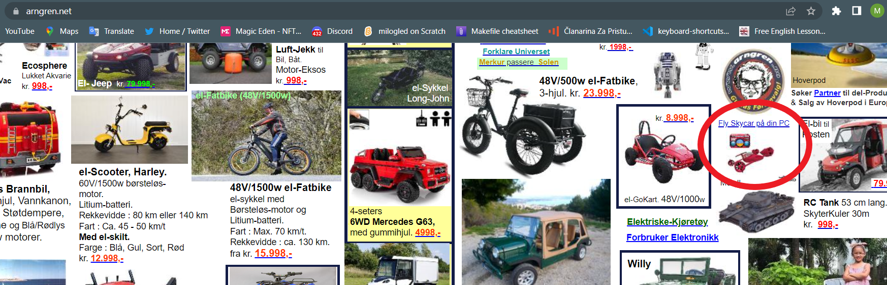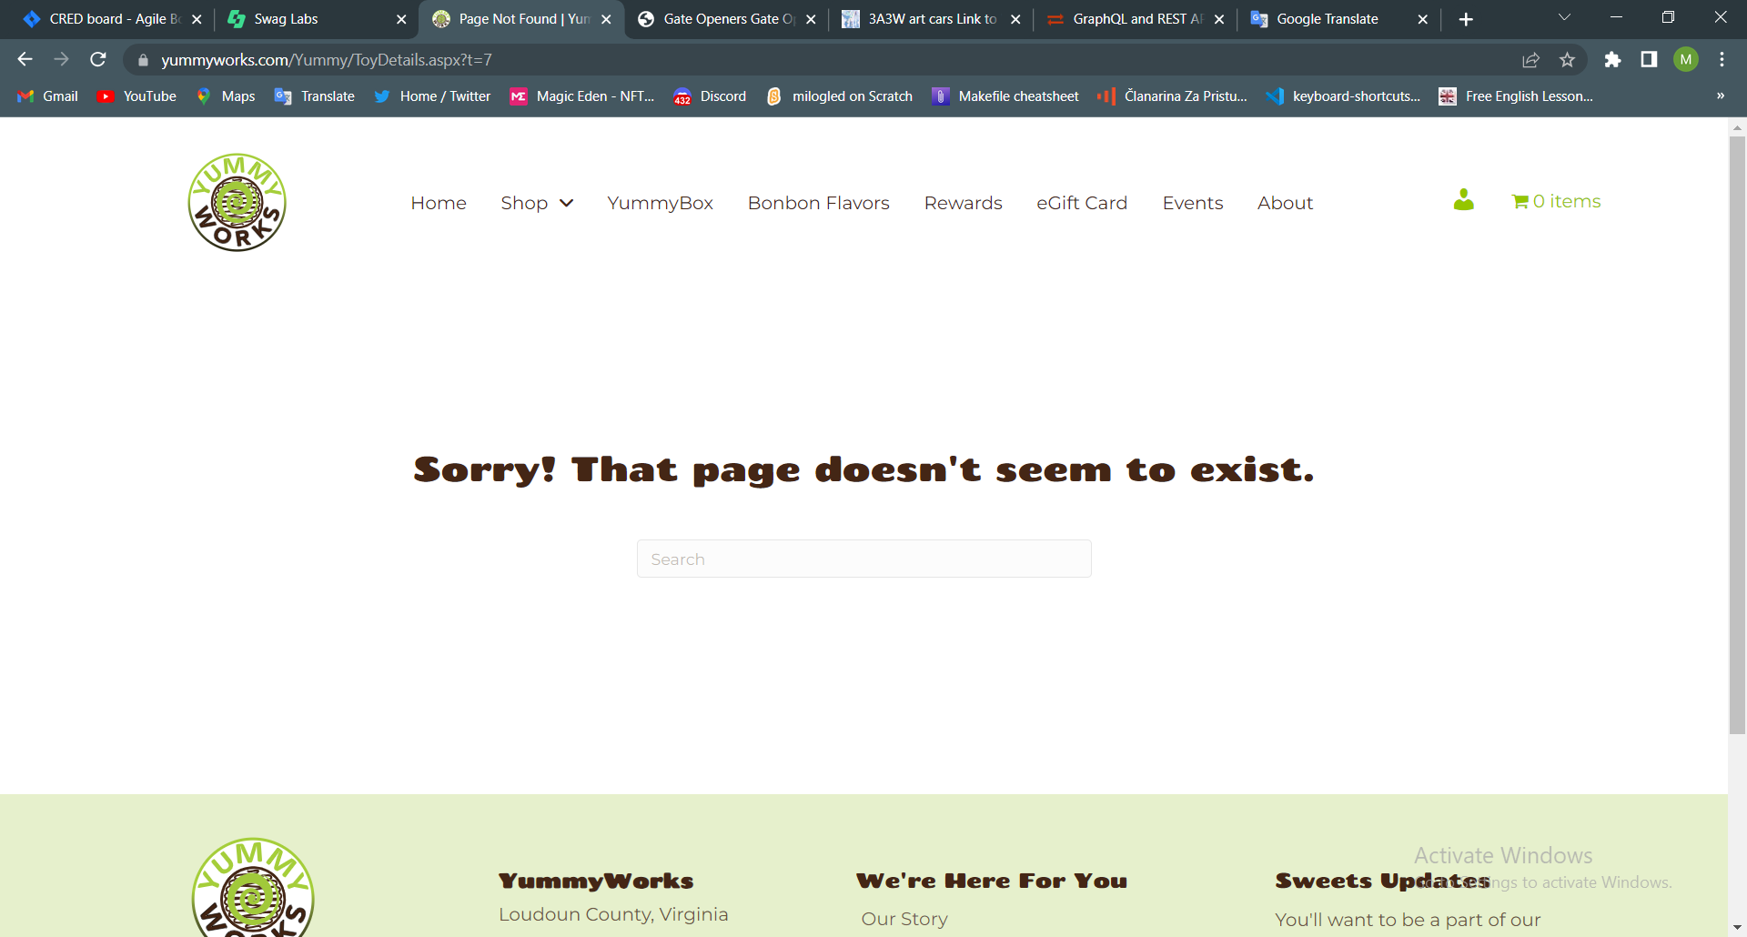

Report 11:

The link to Google Earth does not work

Used device/Browser:

* Chrome (Version 114.0.5735.199 (Official Build) (64-bit)) on Windows 10

Steps to reproduce:

* Open the <https://www.arngren.net/> page
* Scroll to the bottom of the page
* Click the rotating Earth gif

Screenshot:

